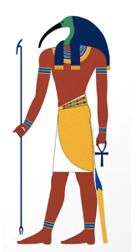 | MANCHESTER ANCIENT EGYPT SOCIETY | 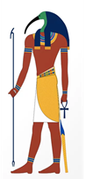
MEMBERSHIP FORM SEP 2025 - JUL 2026
In your pdf, go to the SIGN tab and select FILL & SIGN.
Double click on each box to fill.
TITLE 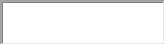 FORENAME 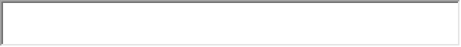
LAST NAME
ADDRESS

POSTCODE 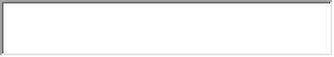 TEL NO. 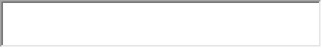

EMAIL
Our newsletter, Djehuty, will be sent by EMAIL. If you are unable to receive an E-MAIL copy, a black and white PAPER COPY will be available for collection at meetings or posted to you.

PLEASE INDICATE WHICH YOU PREFER: EMAIL ☐ or PAPER ☐

DATA PROTECTION REGULATIONS now require your active consent to MAES holding your personal details: Please sign the following statement if you agree to this.
I hereby consent to the Manchester Ancient Egypt Society holding and using my personal Contact details (name, address, telephone and email) for the purposes of MAES administration (Including the sending out of the Djehuty newsletter and MAES notification emails). I understand that this information will be kept safely and will not be disclosed to anyone outside of the MAES committee without prior permission and that I can withdraw my permission at any time.

NAME (signed) 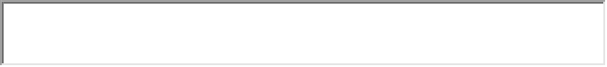
DATE 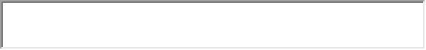

Membership 2025-2026 : £20 (UK) / £21.50 for paypal payments to cover fees
Joint membership (shared address): £20
TOTAL AMOUNT TO PAY £ 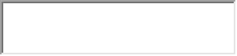

HOW ARE YOU PAYING? (Please tick box)

☐ UK MEMBERS ONLY: BANK TRANSFER PREFERRED;
Details for Bank Transfer: BANK SANTANDER
NAME: THE MANCHESTER ANCIENT EGYPT SOCIETY
ACCOUNT NUMBER: 05535508
SORT CODE: 090151
REFERENCE: initial, surname, “MEM” (eg. S. SMITH MEM)

☐CHEQUES ACCEPTED made payable to MANCHESTER ANCIENT EGYPT SOCIETY.

☐OVERSEAS MEMBERS: PAYPAL TO MAESmeet@gmail.com

Please pay £21.50 if using Paypal to cover membership and the commission charged. **Foreign cheques and bank transfers cannot be accepted**

All forms (and any cheques) should be sent to: Roger Forshaw, Treasurer MAES, 8 Lawnswood Crescent, Adel, Leeds, LS16 8GB

Forms can also be emailed to rogforshaw@gmail.com

Any other membership queries?
Email Hilary Forrest: hilary-forrest@outlook.com

